
Small Shop - Big Results
Repairing Serious Damage – Part 2
By Chuck Behm
Central Iowa Chapter

At the conclusions of last month’s segment, I gave the run-down of a situation that had occurred which would present a challenge to any restorer. A huge gouge on the bottom back corner of an upright we were to refinish needed to be fixed. As mentioned said in the article, I was confident it could be done, although the damage was severe.
Serious case damage is more common than one might imagine. The bottom of the sides of the piano and the sides of the toe blocks are the most common problem areas, but gouges in the front of the keybed, the top of the lid and elsewhere also may crop up from time to time. The key to correctly repairing such damage is in the preliminary preparation of the site.
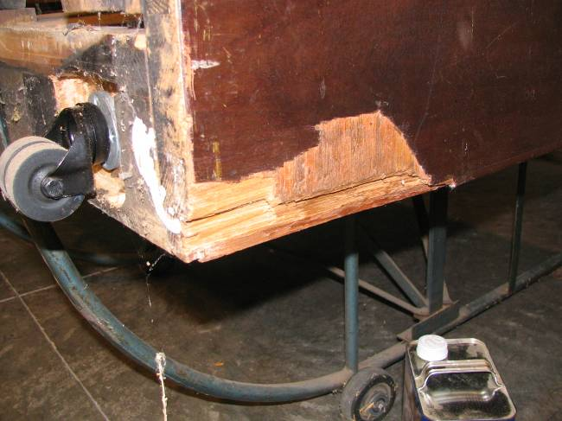

Photo 1:Be cautious when moving pianos

What then, is the process for repair? Simply put, one cuts out the old wood in a manner that a new section of core wood may be installed and topped over with the appropriate veneer. My preference for a piano which is going to be given a natural (not ebony or white) finish is to not use any sort of putty or filler. Even with a piano destined to be lacquered black or white, I would hesitate to use filler in a spot where damage could reoccur. To elaborate on this, consider Photo 1. See how deep the damage extends? The problem with putty or filler, no matter what exact brand of product you use, is the lack of strength that the repaired area would have. Say you did use a putty type filler, smoothed it over and covered it with veneer (or as I saw once on a “restored” Knabe, painted it brown), what’s going to happen when the owner decides to move the piano in his home, and bumps the piano up against the molding along the wall? Most likely a shattered repair, and an angry phone call from the owner to you, demanding that you repair the problem. Again.
The problem is, to make a clean repair without using putty, how do you cut out the old wood? The answer lies in that workhorse tool described before in this series, the plunge router. If you don’t own one, and you have a repair such as this to work on, it’s an investment worth considering, in that it allow you to do the job right. I have found over the years that fixing it right usually involves more time, more energy and more tools but also more of a feeling of satisfaction when the job is done.
If you happen to have a piano in your shop that you’ve been avoiding because of this type of damage, now’s the time to consider doing the job. We’ll tackle the job one step at a time.
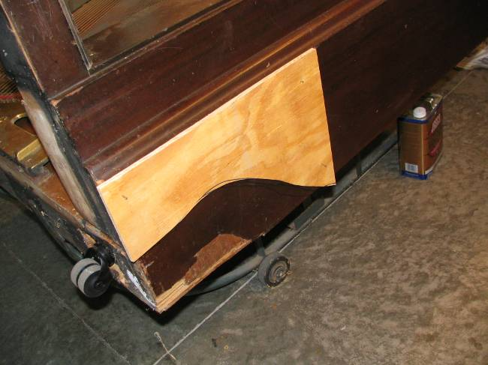

Photo 2: Plywood template in place

1. For this magnitude of a job, freehanding your router, as was illustrated in last month’s featured repair, is not the best choice. More control over the job is needed when the repair is this large. To begin the repair then, create a template or a guide for the router to follow. ¾” plywood is the material to use here. The edge of the guide should come no closer to the damaged area than the distance from the edge of the router to the bit. Cut a smooth, flowing line with a band saw (or coping saw) to mimic the grain of wood. Use
2 inch finishing nails to hold the guide in place, as seen in Photo 2. (Drill pilot holes in the side of the piano for these nails and they will do little damage. A touch of lacquer stick used in the refinishing process will render the small holes produced invisible.)

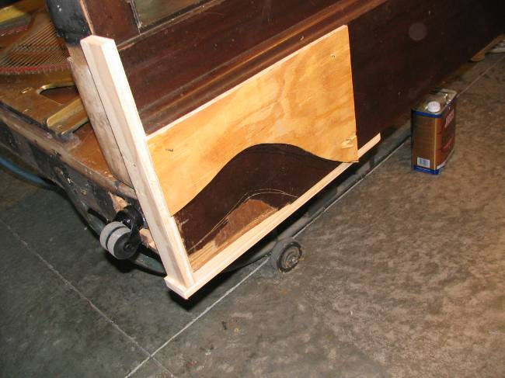

Photo 3: Solid support for router along sides of piano

2. Provide a base for the router around the perimeter of the work. If the damage to the piano is on the edge of the side, this means attaching support for the router to the back and base of the piano (Photo 3), on the same level as the side of the case. The router base must be supported on both sides, or it will be very difficult to maintain an even depth of cut. If the damaged area is so wide that the router is not supported on both sides at any point, the cutting out will need to be done in two stages.
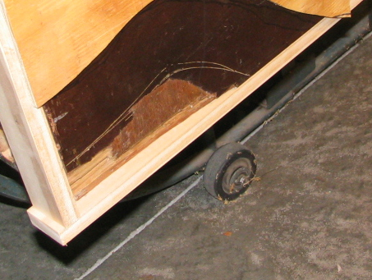

Photo 4: Scratch line marks the edge of the cut to be made

3. Take the time to gauge where the edge of the cut is going to be. If you make a wooden plywood wheel the size of the base of your router, and drive a finishing nail just through the wood (not at the exact center, but corresponding to where the edge of the bit would be), you can run the edge of the wheel along the edge the guide and scratch a line into the old finish that shows where the router is going to cut out. Keep the nail turned in towards the guide. Looking at Photo 4, you’ll notice I did this twice. The first time the scratch line wasn’t quite outside the damaged area. I took the guide off the piano and, cutting off a bit more with my band saw, tried it again. This time the scratch line completely took in the damaged area. Measure twice, cut once.

[Warning – Before proceeding: If you are not experienced with the use of a router, this would not make a good first project. Try your hand at simpler tasks before you attempt something of this nature. Even if you have frequently used a router, be careful. Wear eye and ear protection, and keep focused on the job. Inattention could be disastrous!]

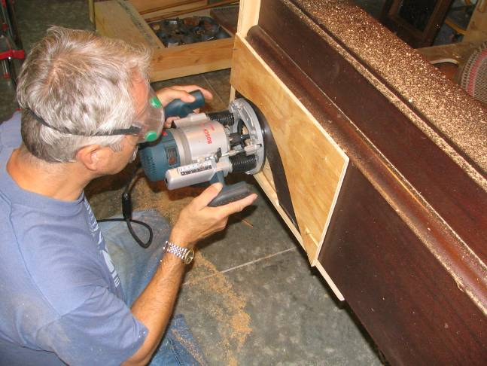

Photo 5: Easy does it

4. Using a ½” by 1” straight bit and with your router set to make a shallow cut, make your first pass over the affected area, cutting first into the overlying veneer (Photo 5). Start by following the curved edge of the guide, and work your way down. If you are working on a deep gouge, the router bit will not touch the majority of the surface on this initial cut. Along the outside edge of the damaged area, let the bit cut slightly into the base you have constructed, so that as you work your way down with deeper cuts, you don’t have to focus on where the piano ends and where the base begins. Just make sure that you leave enough of the base intact to give the router has adequate support.

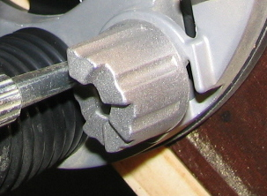

Photo 6: One step at a time

The plunge device on your router most likely will operate in a similar manner as to what’s seen in Photo 6. Notice the staircase design used - starting from the top step, each twist of this mechanism allows the bit to descend slightly deeper into the damaged area. This is a very straight-forward method to use, and very easy to operate.
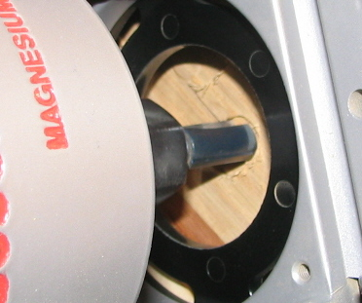

Photo 7: Take the plunge

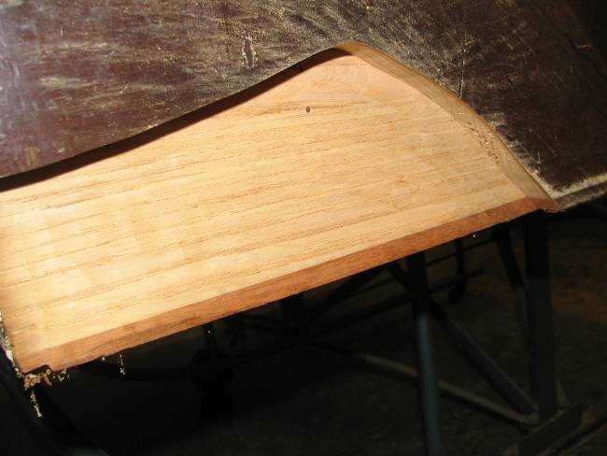
5. Step by step, cut down deeper into the damaged area. With the plunge feature, each cut begins with the bit spinning above the work area. While the bit is turning, it is then plunged down (Photo 7) into new wood. By removing the wood in increments, the operator has more control over the router. Also, less of a load is being put on the motor, thus ensuring longer life of the tool. As you work, swipe the cutter back and forth, until the entire surface is flat.

Photo 8: Ready to replace core wood

6. Once the damaged area has been routed down to good wood (Photo 8), you are ready to start the reconstruction process. Remove the guide and the base which were attached to the piano. You are now looking at a much more manageable repair job. When we return to the project, we’ll be replacing the oak core wood, and then topping it off with mahogany veneer to match the original. Finally, we’ll work with stains to blend the new surface in with the old for an “invisible” repair.
Until next month, from our shop to yours, wishing you the best.

Chuck Behm is the owner of River City Piano Restorations in Boone, Iowa. He can be contacted at behmpiano@gmail.com.

