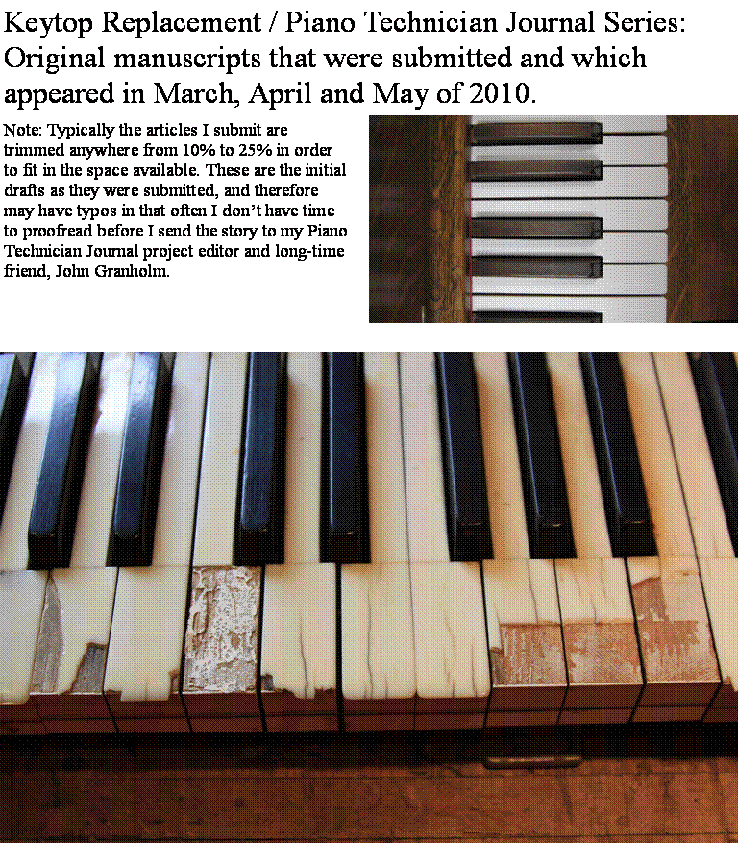

Small Shop - Big Results
In-House Keytop Replacement (With that Outsourced Look) – part 1
By Chuck Behm
Central Iowa Chapter

I doubt any piano technician would argue the point that a poorly installed set of plastic keytops cheapens the appearance of a piano. We’ve all seen sets of keytops so ineptly installed that the question comes to mind, “Why did they bother!?” Done well, however, results can be achieved on a par with professional installers, even with ordinary tools already on hand in most shops. A properly installed set of keytops can add beauty and value to an older instrument. This type of workmanship, with patience and practice, is entirely possible using the right methods.
Many technicians choose, of course, to outsource their keytop replacement jobs for purely practical reasons. Income can be made with very little effort by simply boxing up a set of keys, sending them off to a reputable shop, and replacing them when the shipment returns.
What these technicians are missing out on, it seems to me at least, is the joy of doing the work themselves. The feeling of accomplishment that comes from being able to say, “I did this myself, with my own two hands!” is absent when one allows another technician to have all the fun of seeing the transformation take place. What holds back some technicians from trying keytop replacement might be simply a lack of confidence – that, or simply not knowing where to start. The detailed steps outlined in the following articles are everything one needs to know to do a great job of keytop replacement with a modest shop set-up.

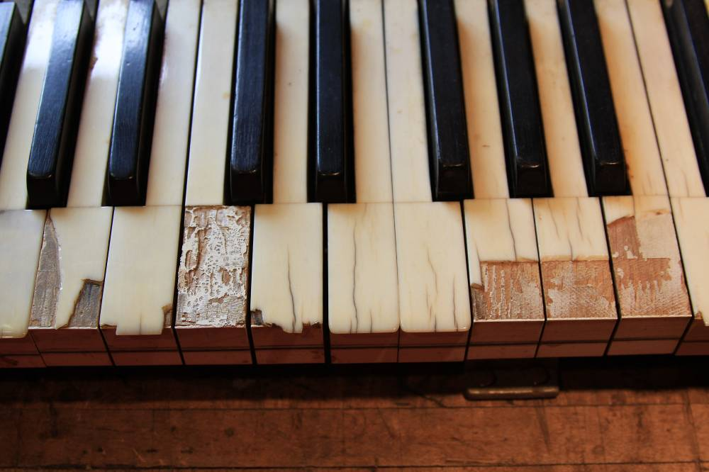

Photo 1: A lost cause.

But first of all, when is replacement the recommended procedure? For one, on any older piano with poor quality imitation ivory – whether it be yellowed, wavy, or chipped. A new set of ivorine keytops, properly installed, can do wonders for the appearance of such an instrument. Also, pianos with original ivory which is damaged beyond hope, such as in Photo 1.

This set of articles will be presented along side a series devoted to restoration of original ivory keysets. This beginning series of articles will present a straight-forward methodology aimed at the ordinary shop owner, using tools already on hand in most restoration shops, molded keytops with fronts for the key covering material, and contact cement for the adhesive. It will show how even at this beginning level, professional looking results are attainable. The compimentary series of articles will explore further methods for restoring original ivory keysets – a artform in itself.
For the shop owner wishing to try replacing a set of keytops himself for the first time, no step will be left out in this beginning set of articles. The devil, as they say, is in the details. Assuming you’ve brought a set of keys, along with the keybed, to your shop to work on, I will give you all the detailed information you will need to know to return those keys looking their best. If this indeed proves to be work that you enjoy, you may find yourself with a great number of jobs. To me, it’s one of the most rewarding repairs that we do, in that it makes such as huge difference in the appearance and playability of the piano.

The first step then, if the set of keytops you are replacing is genuine ivory, is to save any good keytops to recycle later when repairing a set of ivory keys that is in fact salvageable. The larger your collection of old ivory, the more often you can find that perfect match to blend in where needed. To remove the good tops, use an old iron on a medium setting, cover the ivory with a lightly dampened rag, and heat for several seconds. Then, use a putty knife to carefully pry off the keytop (Photo 2). Ivory tails may also saved for recycling, although it won’t be long before you have far more tails than you will ever use.
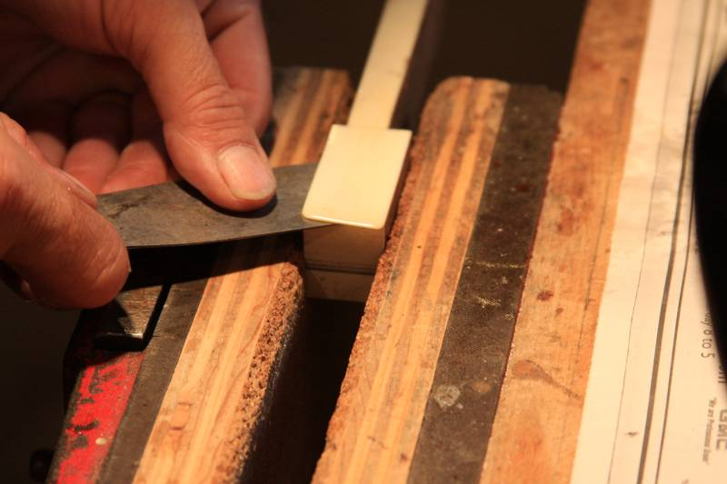

Photo 2: Precious commodity.

Once the good ivory has been salvaged, the top surface of the keytop must be dressed to receive the new molded keytops. Since the new keytop material at .075”is most likely thicker than what is being removed, it is advantageous to actually remove a thin layer of wood in the process, so that the new tops end up at the same approximate level as the old. A variety of tools are used in this process by various technicians. Following is a list the more commonly used tools, with a brief appraisal of their effectiveness in prepping keytop and recommendations for their use in the shop.

1. Disc sander, used either on an electric drill, or on an electric grinder:
Poor control of the amount of material being taken off – the use of any type of a rotary sander results in highs and lows in the surface of the keytop. Not recommended.
Belt sander, hand held:
Fast removal of material, but again, very poor control of the amount of material being used, resulting in an uneven surface. Not recommended.
3. Belt sander, table top or free standing model:
Useful in situations where the removal of wood is unnecessary, but merely the removal of a heavy, uneven layer old glue from the keytop is needed (Photo 3) to dress the keytop for installation of new ivory keys, or imitation ivory of a similar thickness to the old. Even then, a delicate touch is necessary to avoid a keytop that is not tipped from side to side, or front to back. If the removal of a layer of wood from the top of the key is necessary, achieving a satisfactory result is unlikely, as a surface which is tipped one direction or the other is hard to avoid. Recommended, therefore, only in very limited situations.

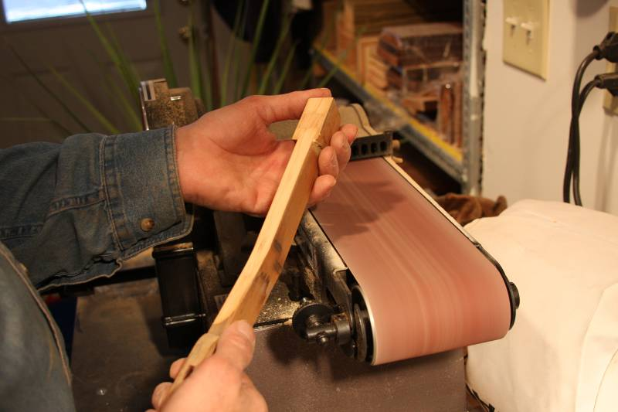

Photo 3: Used with care, old glue may be quickly removed.

(Note: If the old keytop is not crusted with glue, and no removal of wood is needed, dressing the keytop without power tools of any kind may be accomplished simply by placing a full sheet of either 60-grit or 100-grit sandpaper grit side up on a flat work bench, and bearing down on the key as it is worked face-down backward and forward over the sandpaper.)
4. Band saw:
Although a layer of keytop material may be skimmed off with a band saw, the resulting surface may not be as flat and true as needed. Especially in situations where a blade’s width of material or less is to be removed, the blade may tend to wander slightly from side to side, resulting in the top of the key being untrue. Not recommended.
5. Router / router table set-up:
With a 2 ½” straight mortising bit used with a router bolted to a router table, satisfactory results may be achieved. The fence is slid back and secured at a distance from the router blade, so that the keytop is milled down on the backside of the bit, as the key is run in between the fence and the spinning router bit. However, although this method does produce satisfactory results, I would advise against it for the safety’s sake, in that the bit is exposed and out in the open. (Photo 4 shows the set-up in use).
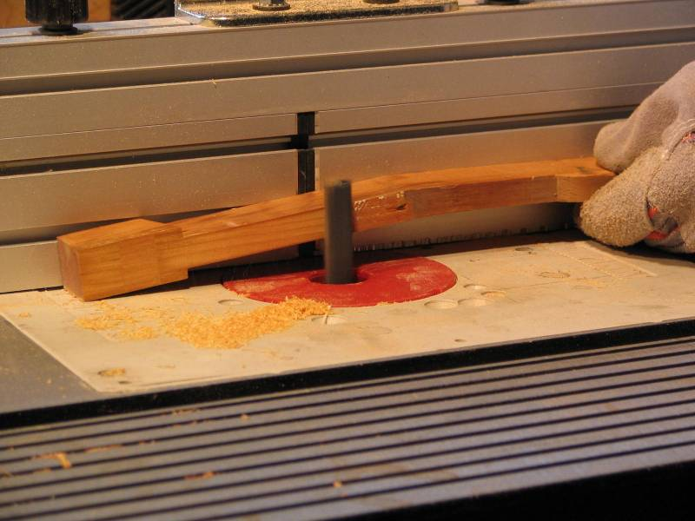

Photo 4: Using the router to surface the keytop.

In addition, because of the counter-clockwise rotation of the bit, and the fact that the keytop is wedged in between the bit and the fence; the bit tends to grab the workpiece and pull it for wards, giving one a disconcerting feeling of loss of control. The surface produced is flat and useable, but because of safety issues, I would vote against using this method. Not recommended.
6. Table saw.
Among ordinary shop tools, the table saw is the preferred tool for preparing keytops, when a layer of wood is to be removed to compensate for a thicker keytop material that is to be applied. As with any power tool, safety precautions must be followed. Compared to the other tools critiqued, the table saw gives one the most satisfactory results, combined with the greatest feeling of control. Its usage will therefore be dealt with in detail. Recommended where removal of layer of wood is necessary.

Preparation of the keytop using a table saw:

Once valuable ivory tops have been removed, (or if the old tops are an older style imitation ivory), the simplest way to finish preparing the keytops for recovering is to cut the old tops off, along with a thin layer of wood, with a table saw. Cutting off the tops, (as opposed to removing all the old key covering material with an iron and damp rag, then using the saw to trim just the wood), saves time that can be put to good use at later stages of the job.
For those shop owners who don’t yet own a table saw, this would be a good time to invest in one. A good quality free-standing or bench-top model will be needed, and will prove to be an all-around workhorse of a tool in the shop. One feature that is worth shopping around for is a good quality fence that locks up square without having to readjust. Less expensive models with cheaper fences will require more time to set up for an accurate job – something to consider when choosing the right saw for your shop. Sometimes purchasing the better quality (and more costly) tool in the beginning is actually the more economical choice in the long run, in that you’ll be less likely to feel the need to upgrade down the road.
To prepare for cutting off the tops of the keys, fully raise the blade and check to make sure it’s square (Photo 5). Even a slightly tilted blade will produce a set of keytops that resemble the shingles of a roof. Also, I would use the square on the keytop itself to double check your work, once the cut has been made, to be on the safe side.

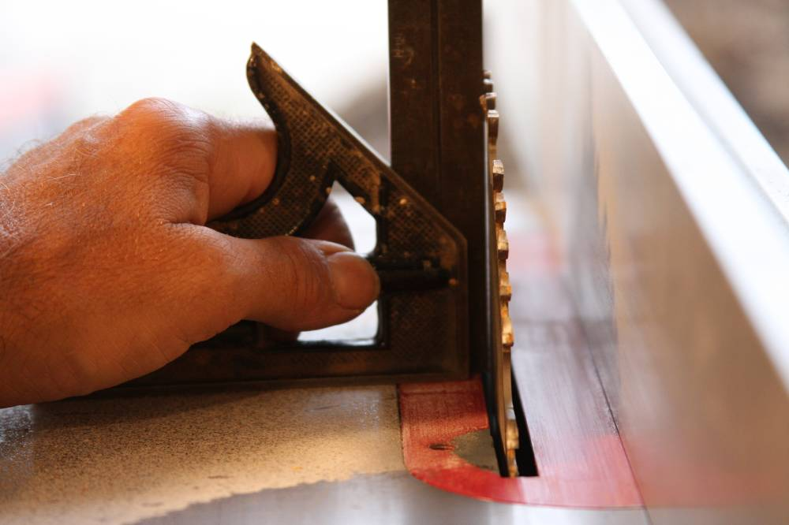

Photo 5: Squaring up.

The blade needs to be raised to its full height, by the way, so that the key will not exit on the far side of the blade. The key will be pushed in part way, then retracted. If the front of the key makes contact with the teeth of the blade a second time, more material will be removed, resulting in an uneven cut. Also, the work must be done without a blade guard in place, which would unnecessarily obstruct the technicians view during the operation. With the blade at full height and without a blade guard in place, the operator should use extreme caution. Fortunately, for reasons to be explained shortly, the procedure is one which is very safe, if due diligence is followed.
Once the 90 degree angle has been set and checked, the depth of the cut to be made will need to be set. The bottom of the key will butt up against the fence, so that the blade will cut the old ivory or ivorine, and top fraction of an inch off of the top of the key. (The amount of wood removed should equal the difference between the new keytop material and the old ivory or imitation ivory). When done correctly, the new keytop will sit at the same level as the old key. The keys will still need to be leveled, of course, but at least there will be no compensation required for the entire set being too high to begin with.
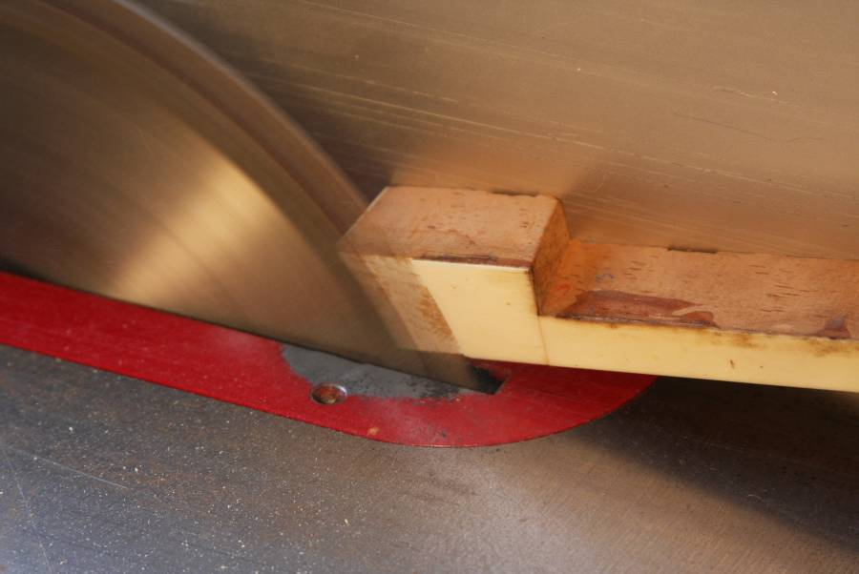

Photo 6: Easy does it.

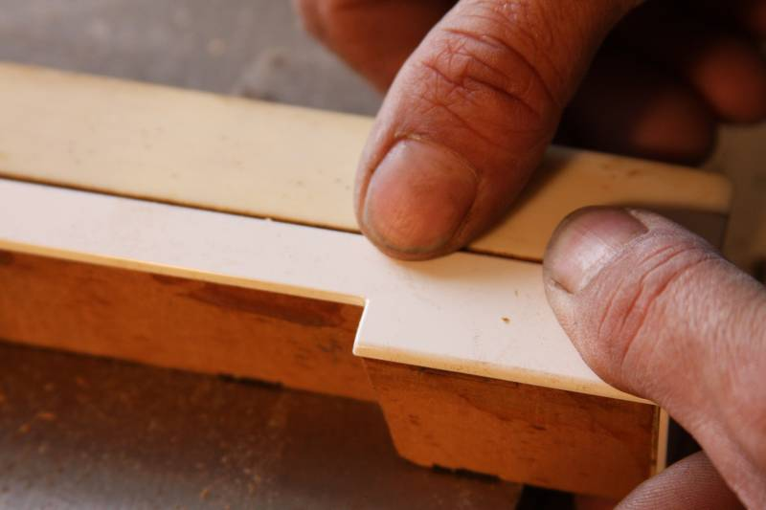
On the initial trial cut, I wouldn’t recommend trying to hit the correct depth the first time, but instead err on the side of too shallow of a cut (Photo 6). That way, you can get a better feel for how much the fence needs to be adjusted, and you can gently tap it a bit at a time towards the saw blade until the depth of cut is correct. For an easy method of gauging this, place a key with the original key cover on the bed of the table saw next to the keytop which you’ve trimmed the top. Place a new molded keytop on the freshly cut top, and use your thumb to feel if the two keytops are at the same height. (If the front of the replacement keytop drops down below the bottom of the key, place the two keytops near the edge of the saw, with the fronts hanging slightly over the edge.) If the new top is still a bit high, adjust your saw and shave off a slight amount more, until there is no “bump” as you run your thumb back and forth between the two tops (Photo 7).
Photo 7: No bumps

One last step before sawing that should be done is to use a straightedge to mark the keytops for the point at which to stop cutting (Photo 8). By doing this you ensure that you will saw back far enough, giving yourself room for the new keytop without having to take an X-Acto knife and trim out a corner. Also, the straight line will help give the finished product an even appearance, as far as the cut line is concerned. (In the advanced series of articles, a method to eliminate the cut line altogether will be explained). Allow ¾” between the back of the new keytop material and the line. (You’ll also notice from the photo that the keys are in the key frame. Removing the frame from the piano and bringing it to your shop along with the keys helps keeps things organized during the recovering process, plus it allows you at a later point to more accurately notch the keys around the sharps).

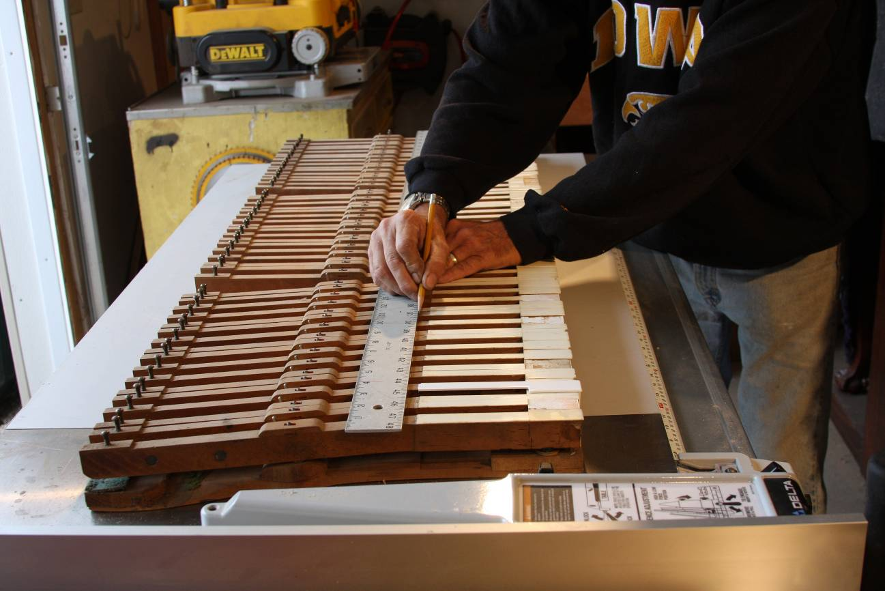

Photo 8: Marking the line.

At this point, you are ready to cut. Begin at one end of the keybed, and pass the top of each key through the blade (Photo 9), keeping your eye on the pencil line where you stop the cut. As you cut, press the key firmly against the fence to ensure that the top is at an accurate distance from the blade.
Before continuing with the process, review the following steps to insure safe operation of the saw during this procedure.
1. Wear the proper protective gear. Safety goggles and earplugs are a must. If the procedure involves the removal of old keytop material, leather gloves and long sleeves(buttoned tightly or rolled back behind your gloves, will be much appreciated, as chips of ivorine tend to zing back at your fingers.
2. Grasp the keystick firmly with both hands, using your left hand to push the key down against the saw bed and sideways against the fence, and your right hand to push it forwards into the blade. (Note: Using a push stick is unnecessary, in that you are not passing the keytop completely past the blade, but retracting it immediately, once the cut is made. A pushstick weakens your grasp of the key, and therefore not recommended).
3. Always keep both hands behind the button of the key. Since the progress of the cut always stops before the button, your fingers will automatically be out of harm’s way.
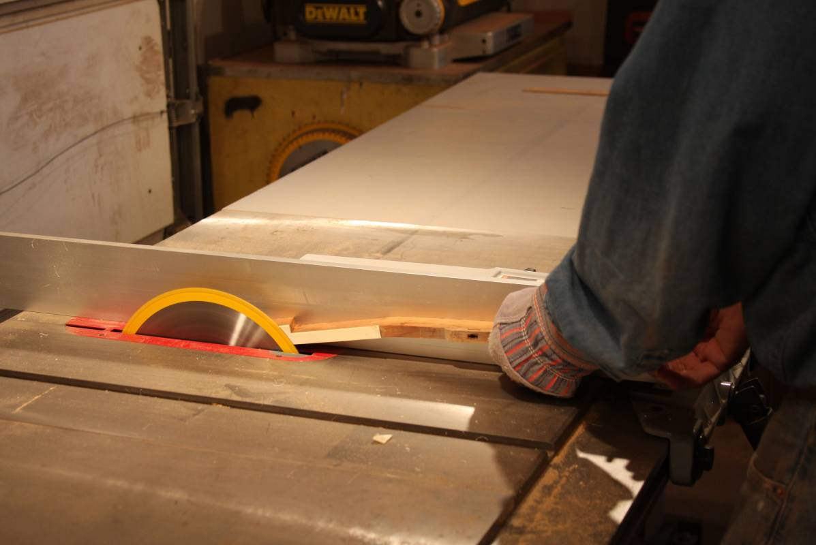

Photo 9: Passing the key through the blade.

You will find that you feel in control of the workpiece, in that the rotation of the front of the blade is downwards, which tends to keep the keystick firmly planted on the bed of the saw. There is no grabbing and pulling away of the keystick such as you have when using a router set-up.
One other precaution is necessary to mention at this point. Certain early ivory imitations, such as celluloid, are combustible. The shavings from these keytops can ignite if in contact with a heat source. For this reason, make sure your saw blade is sharp and staying cool as you cut. If you do not have a dust-collection system attached to your saw, the resulting mound of sawdust from this job should be cleaned up after the job is finished, and not left under the saw to cause problems later.
Once all the keytops have been trimmed, you are ready for the last step of the preparation process, that of removing the fronts. For this step, and several steps to follow, a good quality wood vise is essential. If this is not a tool you currently have, consider investing in one. You will be hard pressed to find a piece of shop equipment more useful than a good vise.
That being said, move your set of keytops to the bench (Photo 10). Starting at one end of the keybed, remove a key from the frame and put it in the vise vertically with the front facing up. Using your old iron and slightly dampened rag, heat the keyfront for several seconds. Taking a sharp chisel, start in one corner with the flat side down and work the chisel across the surface of the keyfront, pushing with your right hand and swiveling the blade from side to side as you pry the old keyfront material off. Work towards the opposite corner, slowing down when you approach the point pictured in photo 11. At the last moment, pop the front off by tilting the blade with your right hand. This will help avoid breaking off the corner of the keystick. If that happens, and it will occasionally, save the broken off piece to glue back on with Titebond.

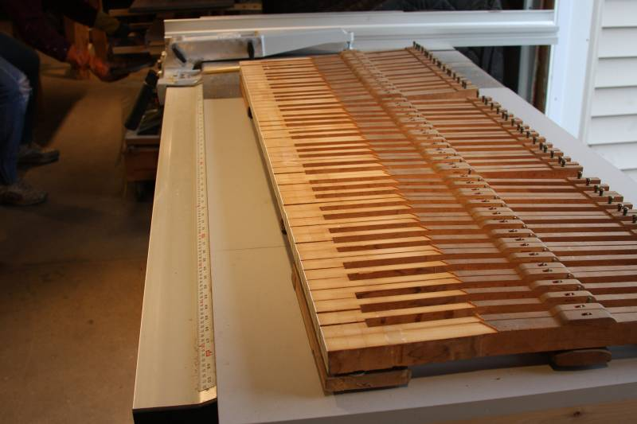

(Other methods to remove old keytops are sometimes needed, with the most hardened on fronts needing to be removed with a table saw. More on this in another article.*)

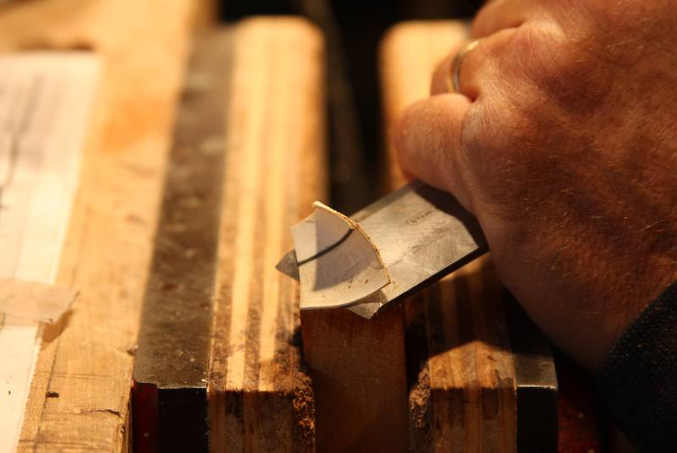
Photo 10: An even line of cuts.

Photo 11: Slicing off the keyfront.

* Some keyfronts are so hard to remove that they must be sawed off. I’ll address that issue in a soon-to-be-released video, “Sawing the Fronts Off Keytops.”

Photo 8: Marking the line. Photo 9: Knowing where to stop is important.

